Scheduling

## User view

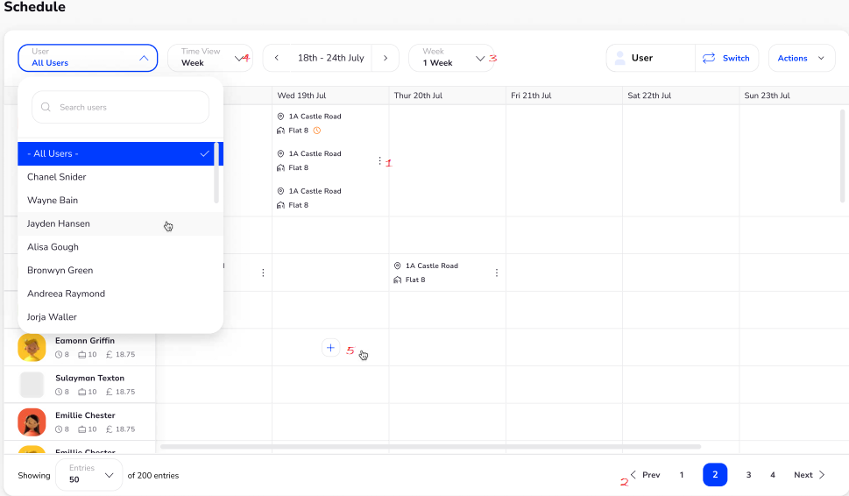

1. The (3 dots) per shift – Click on the dots gives options to **delete shift** or **edit shift****.**
2. Don’t need prev 1234 next. Don’t think we need “showing 50 of 200 entries either.
3. Remove week
4. Give options 1 day, 1 week, 2 weeks and month
5. Click ‘+’ opens “shift to user”
6. Drag and drop whole box to any other box. Can drag and drop single shifts to any box

## Shift to user page

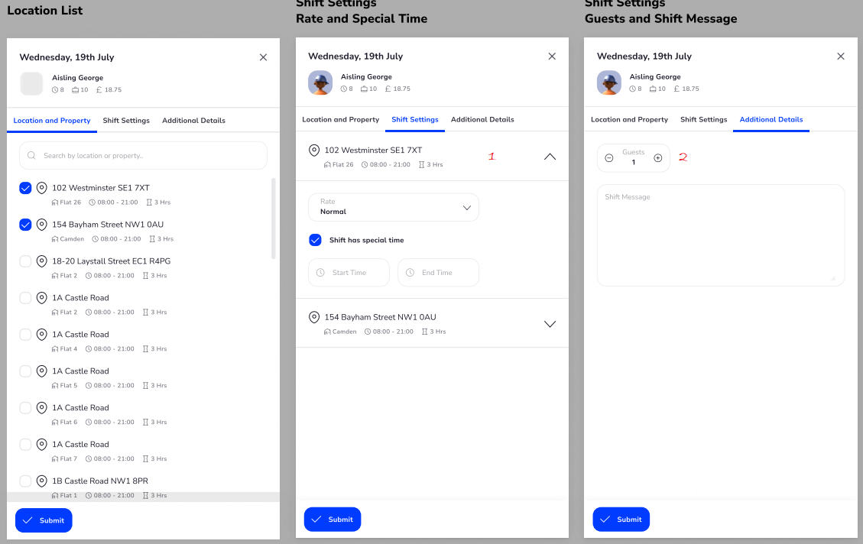

1. Need this for all shifts selected. So of 3 shifts selected on pg1 then 2 shifts to show on shift settings. Each can open up to show “rate and “special time” as shown.
2. If possible, can include guests and shift message on page 2 as this also needed per shift.

## Shift View

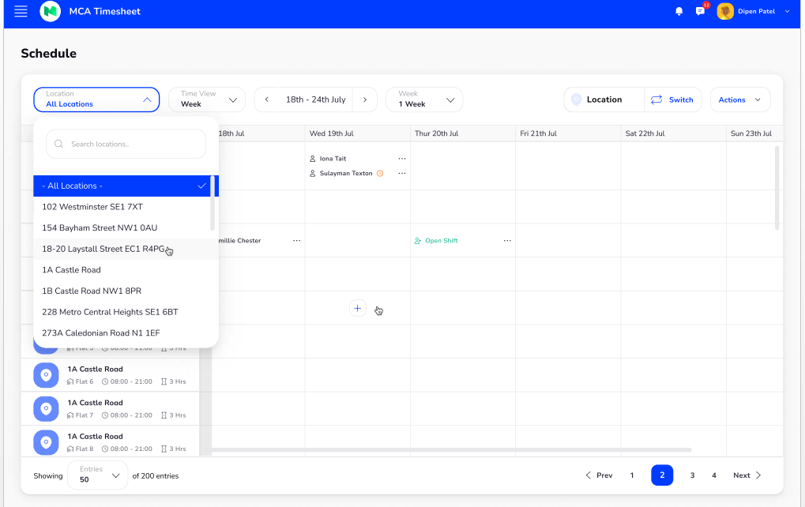

1. Need 3 dots per box not per user. Clicking on 3 dots gives option to “**delete”** or “**Edit”. Edit**  open “**Edit Shift Page****”**
2. The “+” gives option to “**Create open Shift”** or “**Edit Shift Page”**(can open directly to “**open shift page**” then will need to have **create open shift** option on edit shift page),
3. Points 2 – 6 same as user view.

## Edit Shift Page

1. Additional details can go under edit shift page if possible.
2. May need to have “Create open Shift Button on page 1. See point 2 on previous page

## Day View per user

1. No drag and drop needed
2. No per shift view needed
3. 3 dots opens “**Edit Shift Page**” on settings page if possible
4. Don’t need prev 1234 next. Don’t think we need “showing 50 of 200 entries either.

## Day view per shift

This Page not needed.